MECH467 Pre-lab 1

Name: Ratthamnoon Prakitpong

Student ID: 63205165

Email: rprakitpong@gmail.com

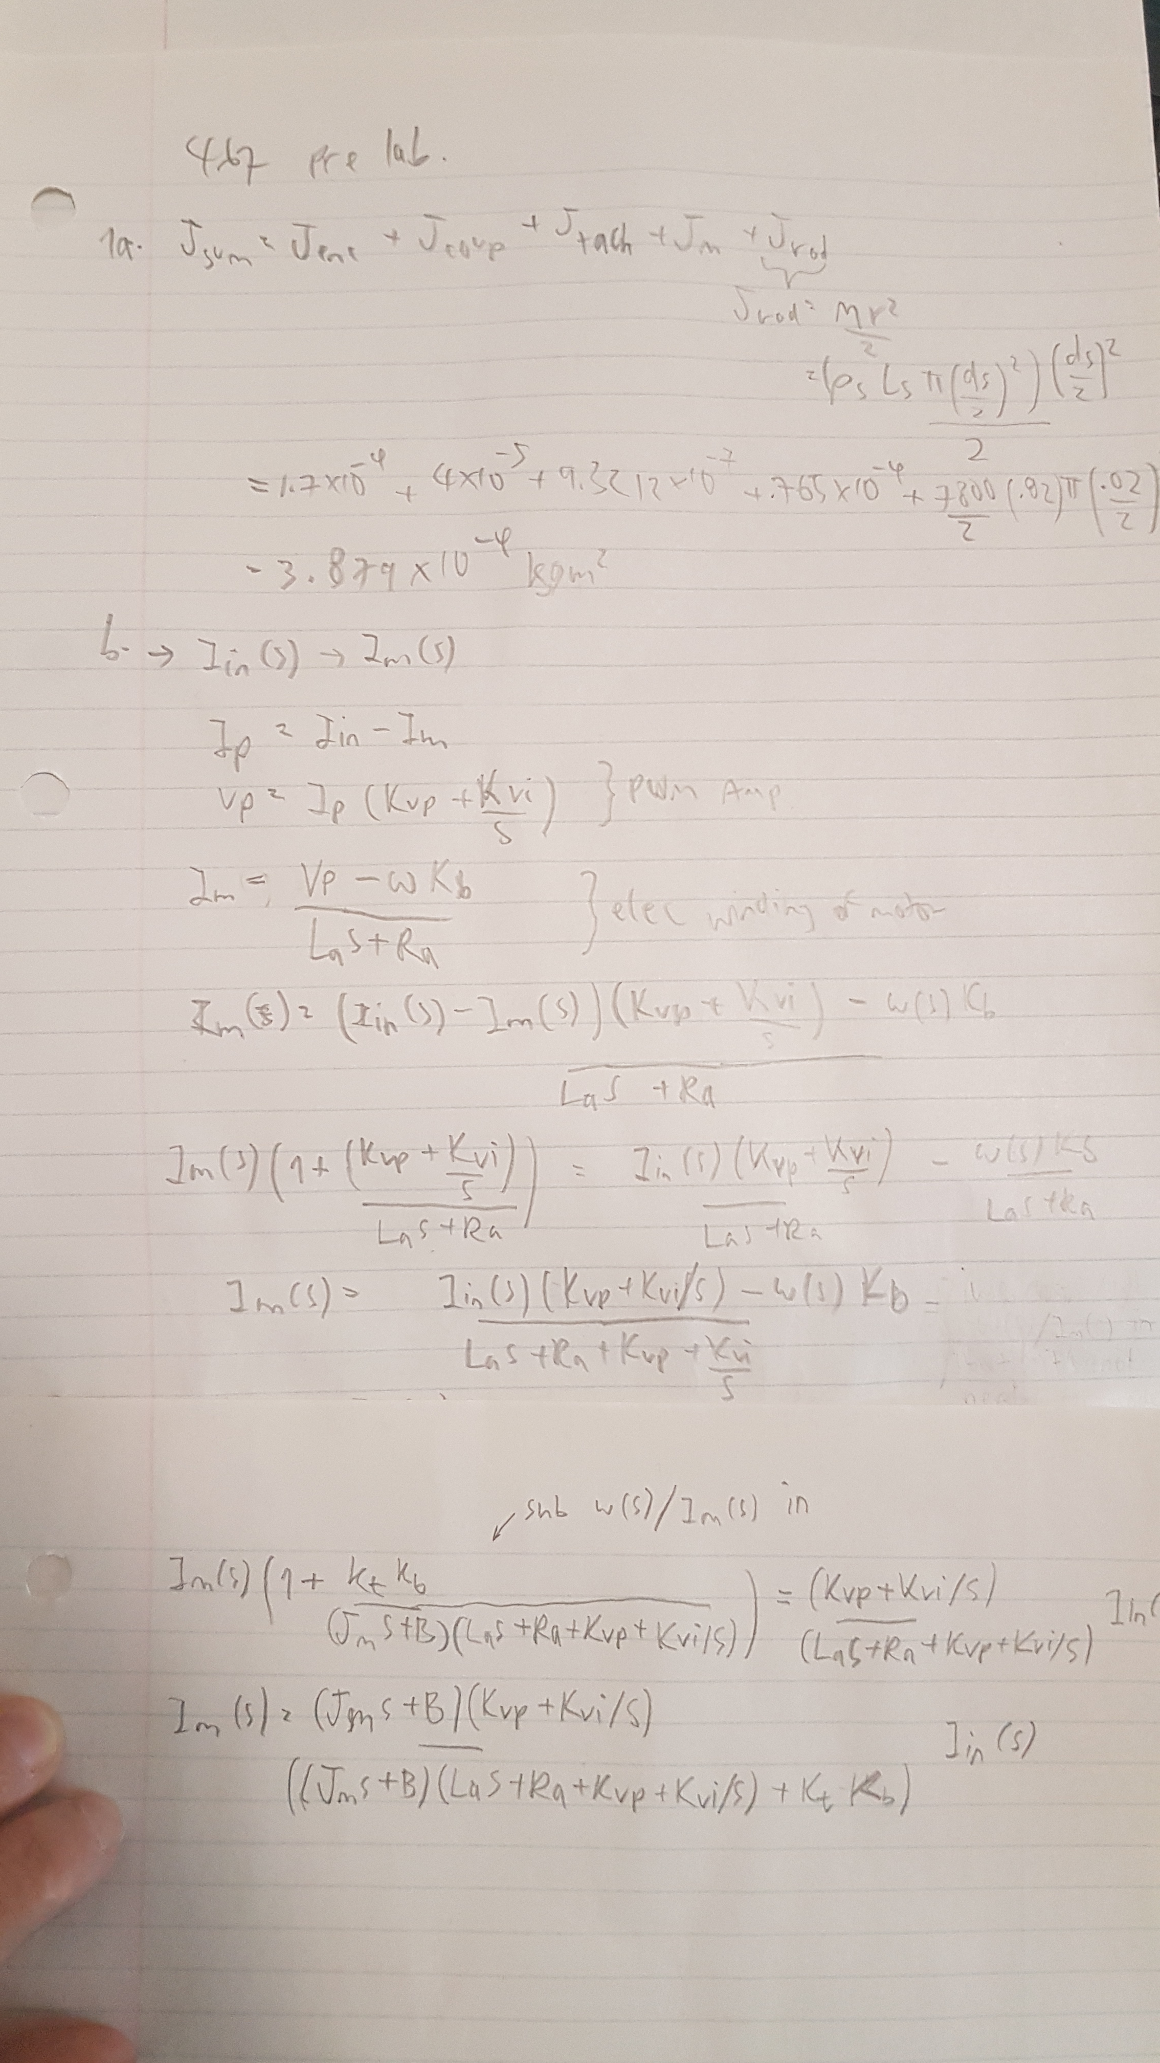

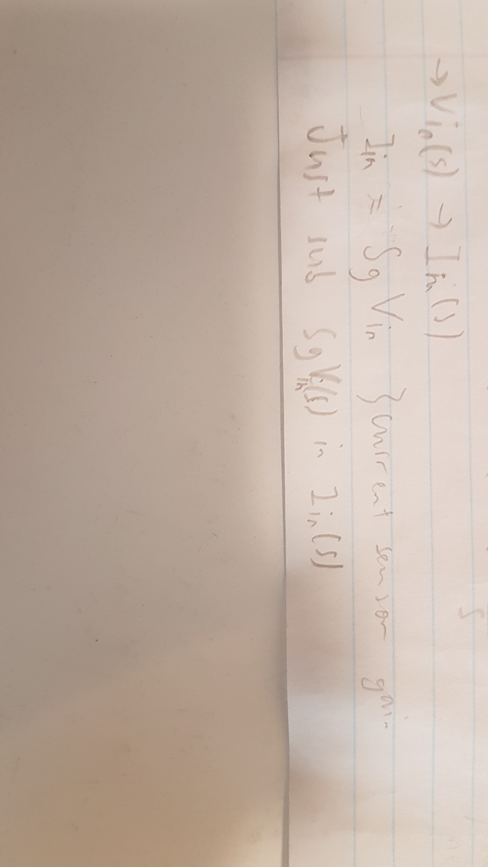

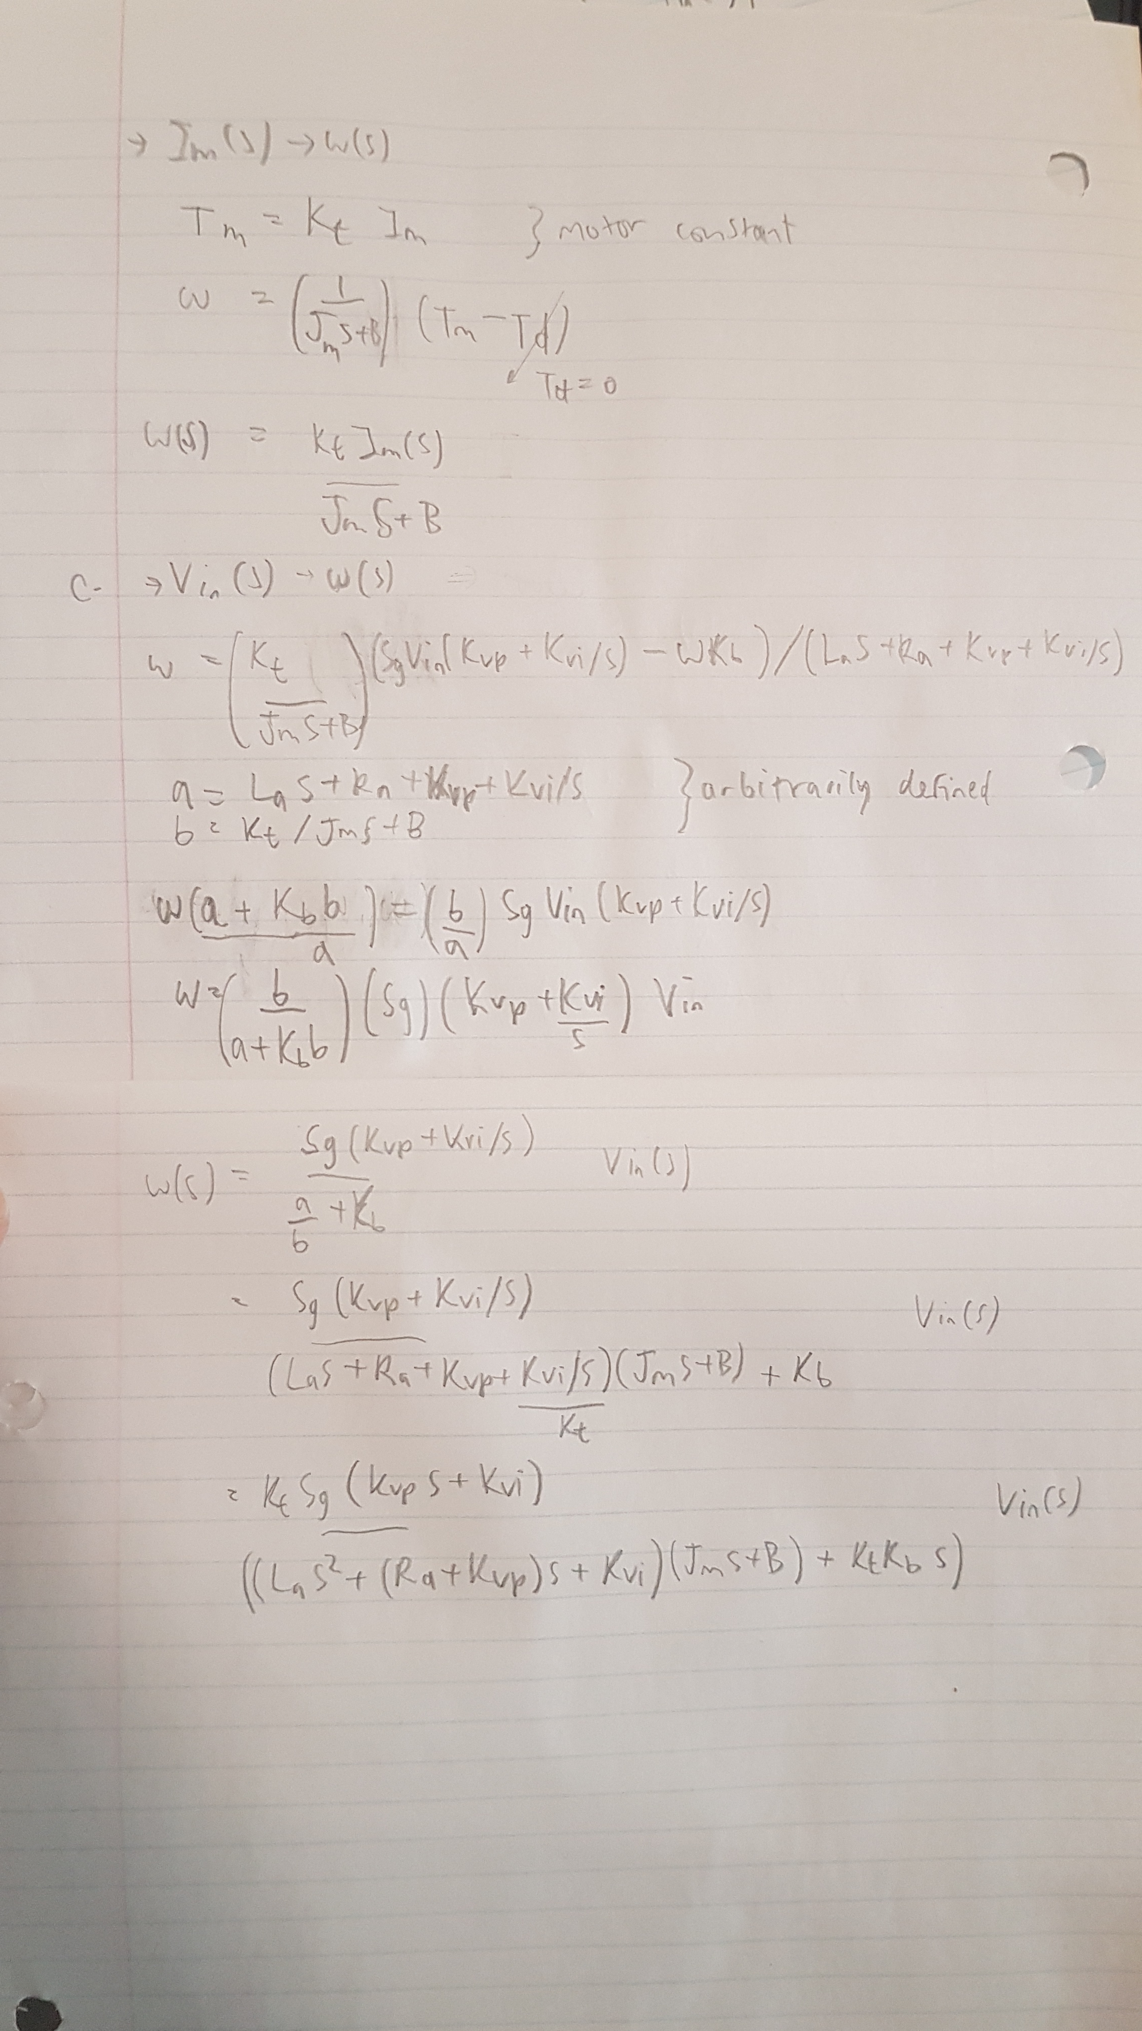

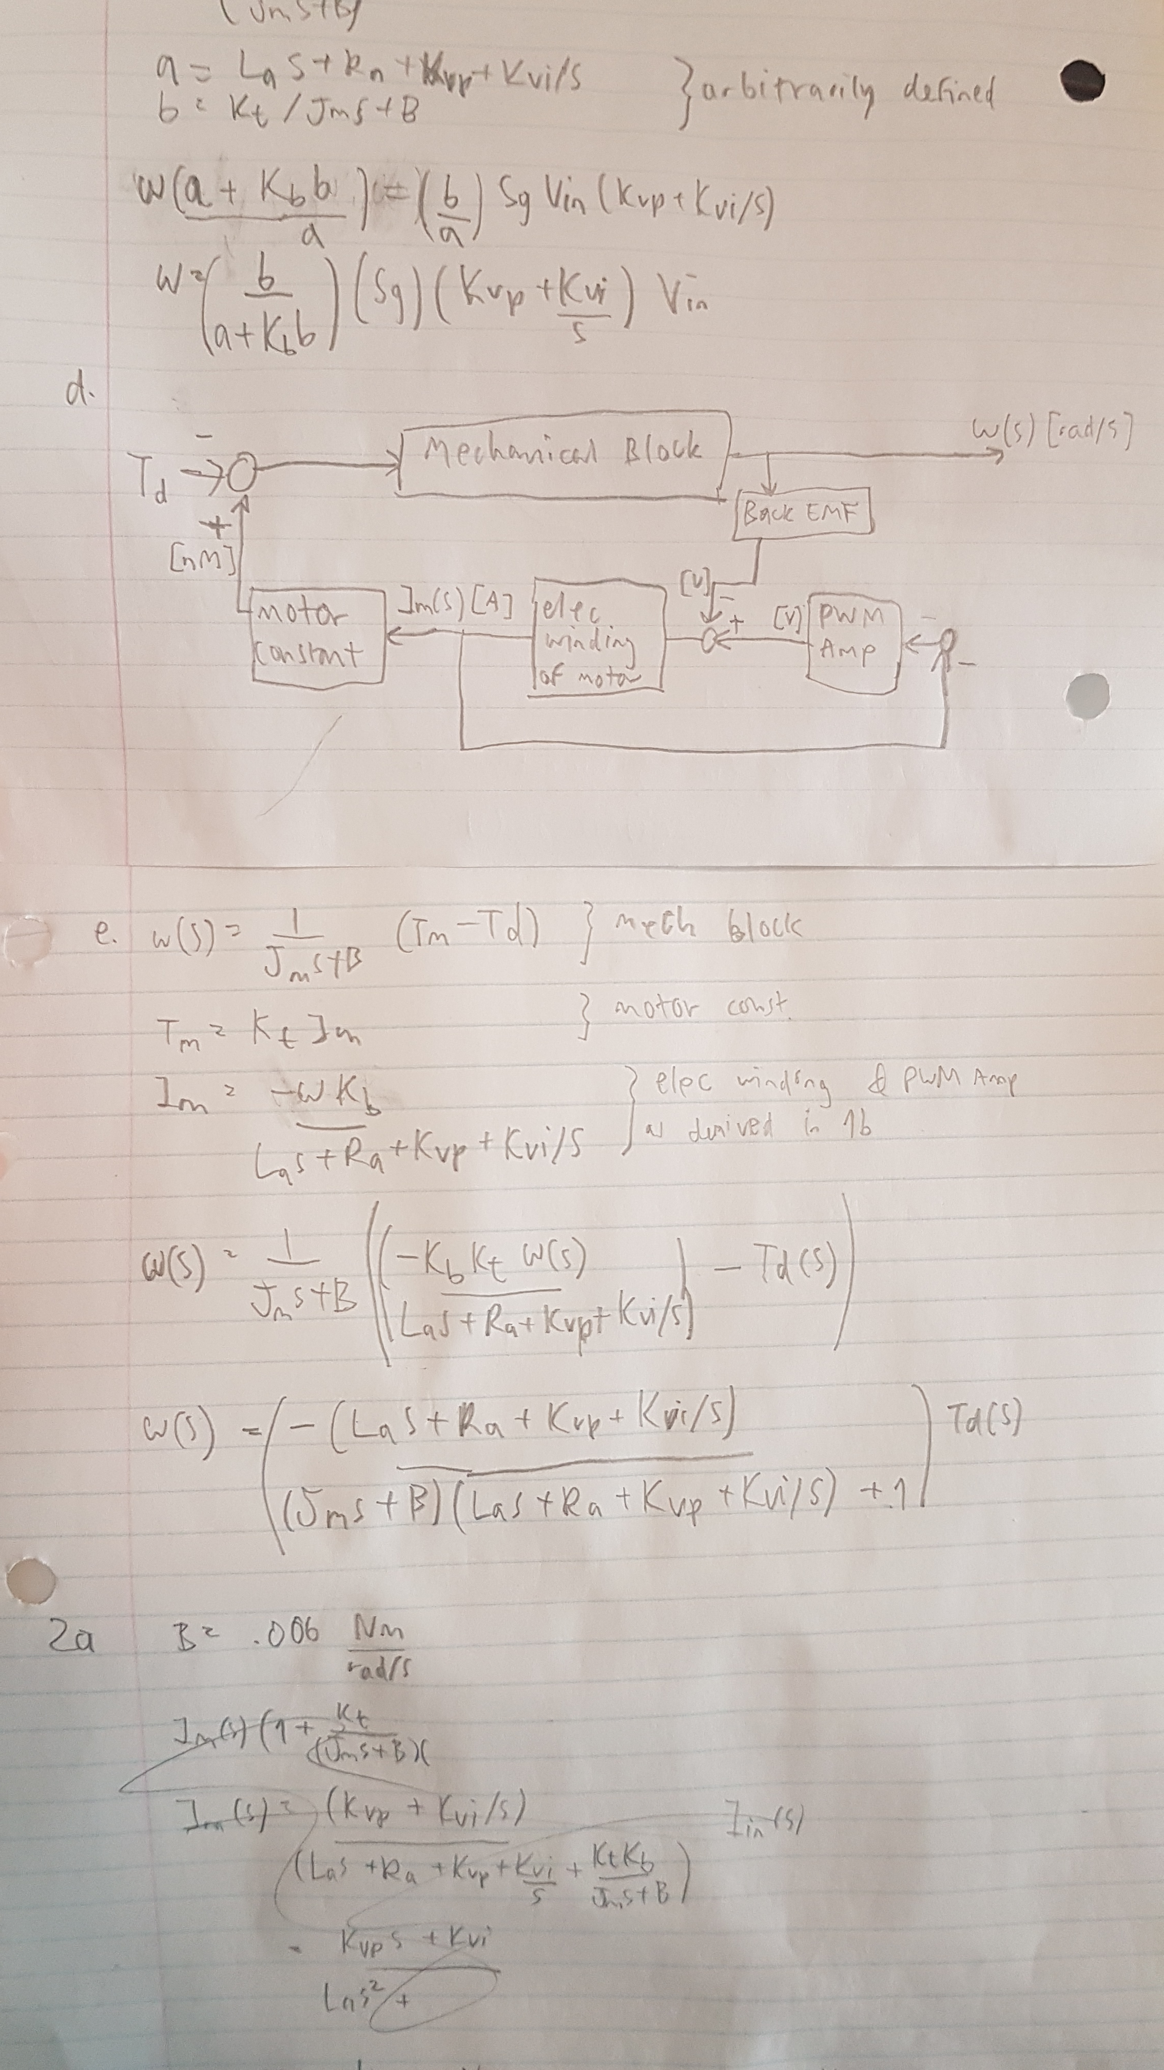

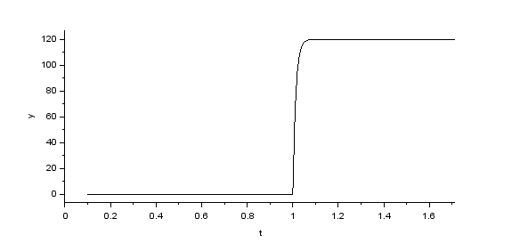2a. w(s)/Im(s)

Step response:

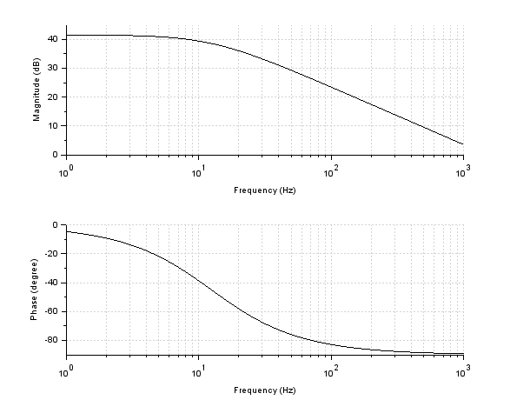

Frequency response:

DC Gain = 120 rad/As

Bandwidth = 77.96 rad/s or 12.4 Hz at ~38.6 dB

Rise time: 0.028 s

t_90% = ~1.0295 s and t_10% = ~1.0014 s

2b. Im(s)/Iin(s)

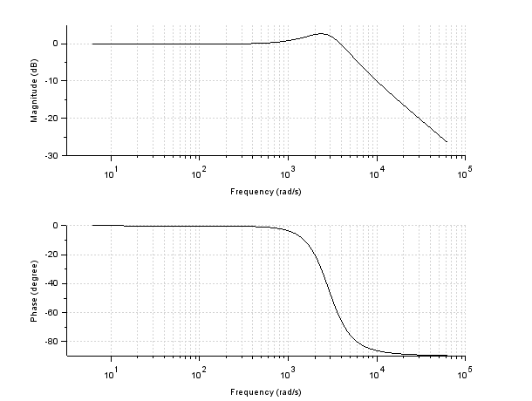Frequency response:

DC gain = 1 A/A

Bandwidth: 5131.0 rad/s

Linear interpolation from (5082.9227, -2.8969316) and (5239.749, -3.2331028)

2c. w(s)/Vin(s)

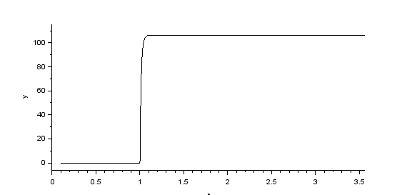Step response:

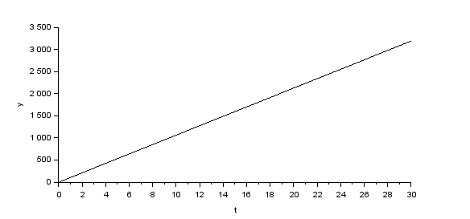Ramp response:

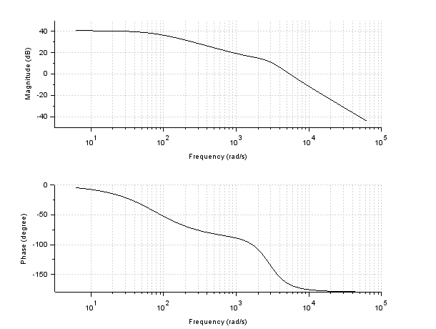Frequency response:

DC gain = 106.44 rad/Vs

Bandwidth = 77.96 rad/s or 12.4 Hz @ ~37.5 dB

Rise time: 0.029 s

t_90% = ~1.0305 s and t_10% = ~1.0015 s

Compare 2a [w(s)/Im(s)] and 2c [w(s)/Vin(s)]:

DC gain is 120 dB and 106.44 dB, where 106.44/120 = 0.887, matching current sensor gain Sg that we used to transform Vin to Iin.

Bandwidth and rise time is the same since there’s no added component that would change them.

Steady state error for a ramp input response:

At steady state, all terms with s will disappear, leaving us with w(s)/Vin(s) = KtSgKvi/KviB, which simplifies to w(s)/Vin(s) = KtSg/B = 106.44 rad/Vs, same as simulated DC gain.

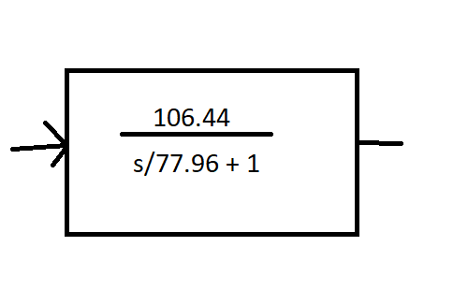2d.

Simplified block diagram:

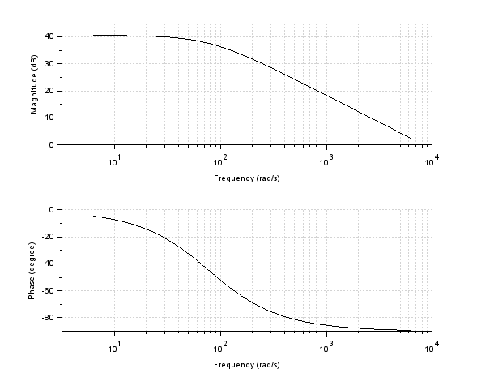Frequency response:

Gain and bandwidth are the same up to 10^3 rad/s, and then it starts to differ.